LEARNING BRIEF

**UCT Global Citizenship: Leading for social justice programme**

**Interim report 1 April – 30 September 2012**

**Introduction& background**

The programme awarded funding by the DG Murray Trust is the UCT Global Citizenship: leading for social justice programme (‘GC’ for short), a co-curricular programme open to all UCT students and supported by the Vice Chancellor’s Strategic Fund since 2010. UCT’s revised mission and strategic plan were adopted at the end of 2009 committing the university to producing graduates “whose qualifications are internationally recognised and locally applicable, underpinned by values of engaged citizenship and social justice” (UCT, 2009)[1].

In response to this changed context and new strategic plan, the UCT Global Citizenship Programme pilot was launched at the beginning of 2010. The programme began with two extra-curricular short courses: *Global debates, local voices (GC1)* and *Thinking about Volunteering: service, boundaries and power (GC2)*. The pilot was seen as a first step towards a broad-based programme of learning which would expose UCT students to global issues and debates, raise awareness of social justice issues and recognise learning from community engagement activities. The first short courses, implemented through CHED, were well received by participants, and 64 students received certificates of completion. In 2011, we doubled these numbers.

In this Learning Brief, we will capture the progress in implementing the Global Citizenship programme in the period April-September 2012. Key issues that will be discussed are:

1. The **GC Award programme** incorporating three revised components
2. The revised short/core course
3. The re-designed workshop series
4. The new voluntary community service component

We will report on the first two of these as they are the aspects of the programme funded by DGMT.

1. The work at **faculty and institutional** level

The work at faculty level has been an important new aspect of the programme this year.

1. Factors **facilitating and hampering** implementation

**A. The GC Award programme**

Based on our experiences with the programme pilot in 2010 and 2011, as well as an understanding of - and in response to - trends in higher education, we renamed and reconceptualised the programme as the ‘**UCT Global Citizenship Award’** from 2012 onwards - an Award programme that students can participate in flexibly throughout their UCT career. The new long term vision of the Award comes out of our experience on the programme in the 2 pilot years and the impetus behind the new design is threefold:

* the need for institutionalisation and curriculum embeddedness
* providing a more in-depth and sustained programme of learning and action over the period of a student’s time at UCT
* financial sustainability

From the beginning of 2012, UCT students could register for one, two or all of **three** components which ran for the first time in 2012:

* The GC workshop series: global debates, local voices (4 themes covered)
* The GC short (core) ***[2]*** course: service, citizenship and social justice
* Voluntary community service (60 hours)

While these components run concurrently, the completion requirements are different for each. For both the workshop series and the voluntary community service, students have until graduation to complete these; students who register for the core course are required to complete it in one semester and cannot carry it over into next year. We have represented programme dates, student numbers and student representation below.

**Table 1: Programme timetable in 2012**

|  |  |  |
| --- | --- | --- |
| **Programme component** | **Topic** | **Date** |
| **Workshop series** | Education | March - April |
|  | Africa in a digital world | April - May |
|  | Sustainability | August - September |
|  | Poverty & inequality | September - October |
|  |  |  |
| **Core course** | Service, citizenship & social justice | 8 sessions in 2nd semester:  4 August - 4 October |
|  |  |  |
| **Voluntary community service** | 60 hours of community service (self organized) | February - October |

We have had approximately **150 students** registered on the system involved in at least one aspect of the GC programme, across all faculties. Overall, we have about **40 students** doing the core course *and* the workshop series, and **11 students** doing all three components of the GC, and a handful of students are attempting to complete all 3 components this year (even though our design assumed more than one year to complete all three aspects). We believe that numbers will continue to grow over the next 2-3 years, and reaching our target of 50 students a year will be achieved. Table 2 below shows spread across programme components and table 3 across faculties.

**Table 2: Student numbers**

|  |  |
| --- | --- |
| **Programme component** | **Registered** |
| Workshop series | 130 |
| Short course | 62 |
| Volunteering | 29 |
| **Total** | **221** [3] |

**Table 3: Faculty representation**

|  |  |  |  |
| --- | --- | --- | --- |
| **Faculty** | **Global Debates** | **Core course** | **Volunteering** |
| Law | 5 | 2 | 1 |
| Commerce | 27 | 13 | 8 |
| Engineering & Built Environment | 14 | 10 | 4 |
| Science | 20 | 11 | 8 |
| Humanities | 60 | 14 | 6 |
| Health Sciences | 4 | 1 | 2 |
| **TOTAL** | **130** | **51** | **29** |

Although there have been some teething problems with our design (we discuss these later in the report), we feel that the shape of the programme is coming to life. Students are beginning to identify with the GC brand overall and we have had most students partake in at least two components of the programme, some even all three, a shift from the pilot years where most students most strongly identified with one of the two course on offer, not necessarily the programme overall.

***1. The revised Short (core) course***

**3rd year engineering student:** Camacho (2004) argues that we need to take cognisance of the axes of power in our service engagements; I think this is something that is important. Our activities can reinforce or help to bridge the gap between those who are privileged and those who are marginalized within our societies. Camacho states that we need to start deconstructing the social hierarchy that exists between the server and the served. I find this hierarchy unsettling when I do service work and I believe that efforts to get rid of it would improve the service experience.

From the beginning of 2012, the core course has had a new title and included a new element. It is now called ‘Service, citizenship and social justice’ intentionally drawing attention to the relationship between service and citizenship, in the context of social justice values. The course added a session on ‘citizenship and service’ and also included 10 hours of community service organized as part of the course.

This year the course was very successful in retaining students (a problem we battled with in the past two years).  Out of about **62 students** who signed up, we had 51 participating actively in the course and **45** should **complete** all requirements of the course. We strongly believe that the shared community service component contributed towards this in no small measure.

**PhD student in virology:** On a personal note, a major lesson I learnt from this visit was that community service does not only involve donating sums of money to organizations of this nature, but it is also to  give up a little bit of your time to do whatever you can do to make a difference. It was a day where one had to put their heart into everything that was needed to be done, and also open your mind to learn from everyone around you (and have lots of fun in the process!). That was the key to making this experience worthwhile. I think that the love and warmth that the women at Mothers Unite showed to us made all the difference. That is the secret behind their success. It was also a day that I learnt about the courage, strength, tenacity, and determination that women have inside them, which could potentially transform the societies that they live in. The fact that this was done on Women’s Month was very fitting indeed.

This core course is an intensive reflective experiential learning curriculum that deals with issues of service, power, inequality and citizenship. Whereas many ‘service learning’ courses focus on learning something other than service through the use of a service experience as part of a course, this course is more about ‘*learning service’*: the focus of both the experiential *and* classroom component is about learning and thinking more about service.

This approach is born of the view that many service learning courses make assumptions about students’ understanding of service, and it is used as a tool, albeit a potentially good one, to learn about a content area while performing a service. The service completed, while usually negotiated with the community, is mostly linked to course content (e.g. business studies completing a funding grant for a community and learning marketing and fundraising skills, sociology students working with a community on a social research project). In the case of the GC short course, students’ knowledge of how to engage in service was not assumed; it was taught and debated, through classroom readings and reflection, and community service activities that were directed by the community. The student comment at the beginning of the report attests to this.

The following topics were covered in the course this year:

* self and service (session held on site in and with the community)
* service in contexts of inequality
* paradigms of service
* development (session held on site in and with the community)
* thinking about organizations
* service and citizenship (new session in 2012)
* sustaining insights going forward.

Successful completion of the course depended on

* 80% attendance;
* participation – in class and online;
* submission of written work – 3 online reflective blog posts and 2 longer reflective essays.

Sessions combined group discussions, learning activities and reflection exercises. Two classes of 25-30 students were held every week (5-7pm). Sessions were facilitated by a combination of tutors (students from previous years) and the course convenor. We drew on experiential learning and the action-reflection cycle in our classes, providing students with an opportunity to look critically at their own views and experiences, and to listen actively to the views and experiences of other students. We built this approach into the ‘ground rules’ for participation and learning that we establish jointly at the beginning of the course.

Extensive use was made of the online tool of blogging in this course. This is because it is a tool that lends itself towards critical reflective activities, the key pedagogical mode of the course. Students attended a training session on the use of blogs, which also included an introduction to the online learning platform, Vula. While students do use Vula for their other courses, the use of it in the GC programme is far more interactive and extensive. The positive impact has also been seen in blog responses students recorded.

*Citizenship and service*

The new session added to the short course which links citizenship and service was introduced this year for two main purposes:

* citizenship is reflected in the title of the programme overall and we felt it important to engage students consciously in thinking about this issue;
* having a component of service included as a common experience in the course meant that we could introduce the notion of citizenship in a grounded way, linked to enacting it via community service in one’s local community.

|  |
| --- |
| **1st year engineering student:** What characteristics does a good citizen have? This question draws many answers from people who go through different experiences in life. My view of this issue goes down to tolerance. We live in a world where society is too judgemental on each other’s way of life. Accepting the fact that there are different people out there is the first step to being a good citizen. l found the articles “Cultivating Humanity” and “Global Citizenship: What Are We Talking About and Why Does It Matter?” focussed very much on university graduates understanding the different situations in societies and then using his or her knowledge to adapt to those different societies.  I concur with that point because l believe the communities out there are looking at universities to produce individuals who are not only skilled to solve problems but rather individuals who understand and appreciate the people’s cultures and different environments that they work in. |

*Community Service component*

We worked with a CBO in Lavender Hill, Mothers Unite (see [www.mothersunite.org.za](http://www.mothersunite.org.za)) on 2 Saturdays during the second semester. Introducing service into the course proved very significant for three main reasons:

* it introduced students to a service opportunity – while many students are involved, others aren’t
* it provided an opportunity for us to begin building a partnership with an outside organization
* it contributed significantly to building a sense of class identity

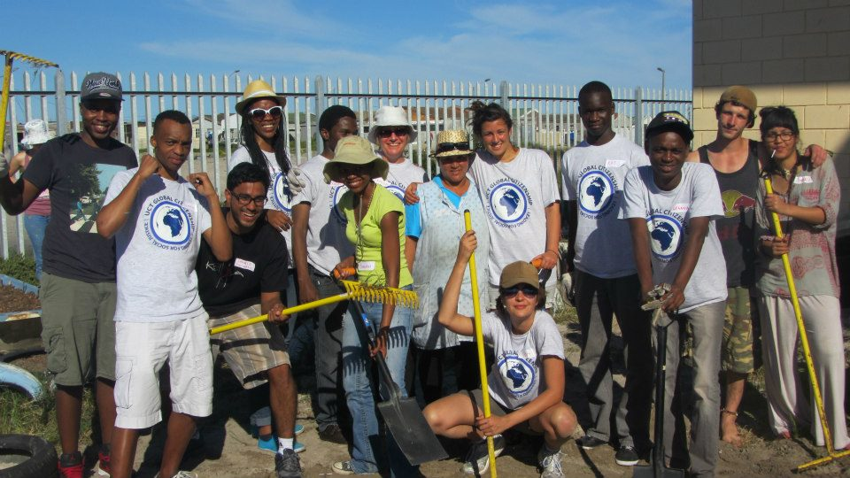

GC students in gardening team at Mothers’ Unite, Lavender Hill (September 2012)

We went out for two Saturdays during the course. On each of these occasions, we combined a class with service activities that the organization had identified. These activities included painting of offices (in the shape of shipping containers), covering library books, gardening and laying the foundations for a vegtable garden for children, and laying a carpet in the training room. On the first Saturday, we explored issues of self and service, looking critically at the relationship between identity, intentions and service. On the second Saturday, we explored our meanings and understanding of development.

***2. The re-designed workshop series***

In 2012, 130 students signed up for the workshop series and a varying number of them have been active thus far across the different themes. The programme ran 4 themes, each with a combination of online and face-to-face components, and sometimes including required activities at the end. As part of our plan to create a suite of theme choices which we could mix-and-match each year, we developed four new themes this year:

* Questioning education
* Africa in a digital world
* Sustainability
* Poverty and inequality

This means we now have a core design and materials for 8 themes[4] which we can draw on each year. Three of the new themes link to UCT’s strategic research areas which allows us to tap into the institutional resources, and in 2012, we made good use of UCT and associated academics.

* **Questioning education**: Dr Jonathan Clark (who heads up the Schools Improvement Initiative, SII) helped us design and run the Education workshop in March
* **Africa in a digital world**: we consulted several experts for advice on design and materials including Prof Gary Marsden (Computer Science), Dr Marion Walton (Film & Media Studies) and Shihaam Shaikh (OpenUCT)
* **Sustainability**: we focused on food security and drew in science journalist and journalist, Leonie Joubert, who recently published “The Hungry Season” on food insecurity in SA to help with the Hunger Café event.
* **Poverty & Inequality**: designed and facilitated by popular educator, Professor Astrid von Kotze, we invited Dr Frank Matose (Sociology) to contribute, and linked our theme to the Carnegie3 Conference which took place shortly before the theme ran.

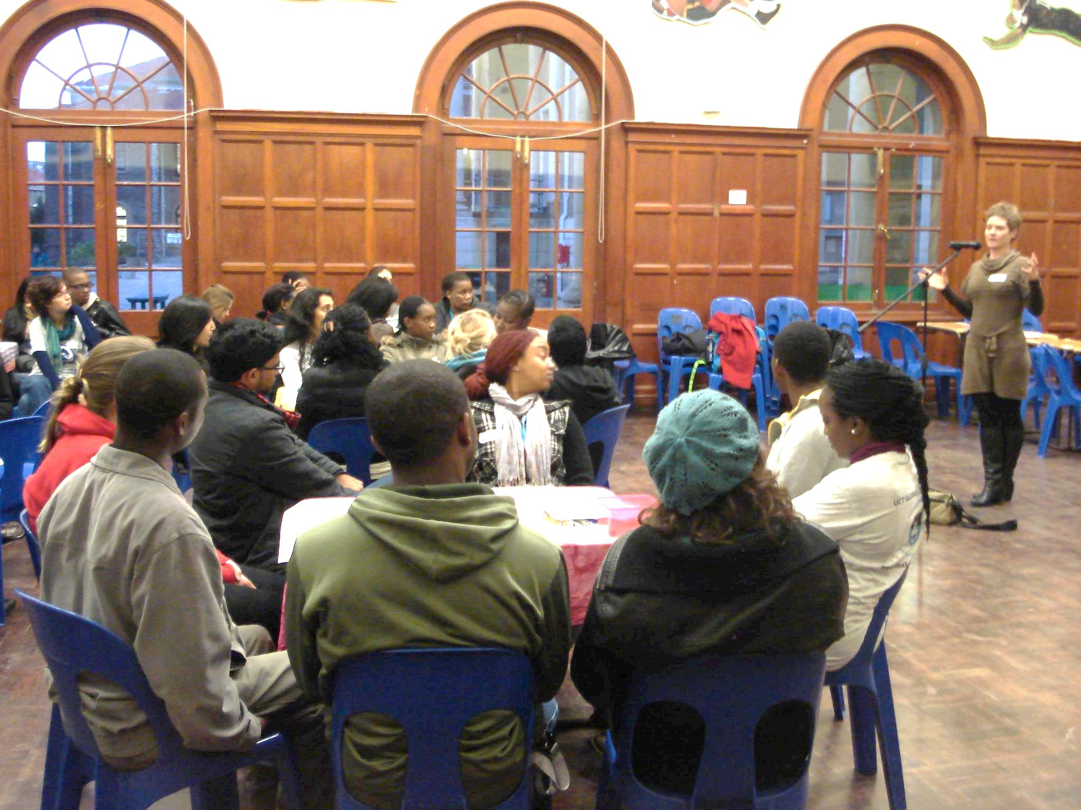

Author of “[The Hungry Season: Feeding Southern Africa’s Cities](http://www.amazon.com/The-Hungry-Season-Southern-ebook/dp/B0096MJ2OI/ref=sr_1_1?ie=UTF8&qid=1347396351&sr=8-1&keywords=the+hungry+season+leonie+joubert)” Leonie Joubert addresses GC students at The Hunger Café workshop event (August) on the issue of sustainability, through the lens of food security.

One of our goals in 2012 was to make more direct links between the idea of critically thinking and debating about issues to taking action/doing something about the issue. Thus, in each theme we tried to provide some impetus for students to take direct action. For instance in the Education theme, we invited 8 NGOs working in the field of Education to attend our workshop and talk to students about what volunteers could do. When dealing with sustainability, students were asked to post on the Facebook page about they could do to make a stand about sustainability. One student got involved with school groups who were planting food gardens at their school and two students provided links about where and how to do recycling.

For the Poverty & Inequality theme, we challenged students to do something to ‘conscientise’ other students or their own family or friends. Two groups of students arranged times to show DVDs and lead a discussion.[5] One of the main purposes behind the workshop series is get students to actively engage with each other about what they i) think and believe about key problems facing the world and ii) how they can act. In the following extract from the Poverty & Inequality online forums in October, the lively and challenging exchanges between students about poverty and wealth show evidence of this:

|  |
| --- |
| **2nd year Humanities student**: “I think that we should ask the question about poverty differently, precisely because changing the questions challenges our perceptions of the problem. That is important because our perceptions are often part of the problem: we disable/passify people we think are helpless victims of poverty, but by focusing on these people, we let wealthier people off the hook, because they do not feature as part of the problem's definition or solution.”  **3rd year Commerce Student**: “From my point of view, the prominent theme here is that of inequality which continues to exist and even become more evident in modern societies. We have very rich people on the one hand and unbelievably poor individuals on the other. It is this 'gap' between these individuals which is a problem. Some measures of redistribution are required to 'even out' this situation, thereby empowering poorer individuals while not taking everything away from the wealthy. I think tax policy can play a significant role here, as can price discrimination of different types of goods’.  **2nd year Commerce student**: “With that said I have a very big problem with excessive wealth. Living comfortably is very different to earning more in a year than what you can spend in a lifetime. The article above asks the question of why we do not have a maximum wage. I think that is an excellent question. One of the points that the article makes is that if you have wealth you can make more wealth with relatively little work but if you do not have wealth you work incredibly hard just to get by”.  **3rd year Science student**: “Interesting points raised above. I agree with L. about putting a limit to wealth accumulation. One way of doing this can be by implementing the same concept used for carbon taxation. But the problem will be how to distribute the money made from these taxes to serve its purpose of levelling the inequality gap and whether we do have capable people to carry out these duties”  **4th year Health Science student**: “This sort of discourse where the dichotomy is phrased in such a way that is seems to be purely an economic difference ignores the real social and political challenges which perpetuate the advantage of some and the disadvantage of others. The failing education system in South Africa is only a problem for the poor. In fact Jansen spoke at an event in Cape Town last night and highlighted the problem that because the wealthy (including MP's) send their children to private schools, the crisis of public education in the country is easily ignored. I think that if we want to start finding ways of really addressing poverty, we need to start linking poverty and wealth rather than separating them (so that those in power feel affected by poverty) and so are inspired to act.” |

Students from all six faculties were represented at debates and as in the previous two years, students commented on much they enjoyed engaging with students from different backgrounds from their own. We never envisaged the workshop series to be run for the general public although we do encourage students to bring friends to certain of the events even if they are not registered on the programme.

From the beginning of this year, we changed the structure to allow more flexible participation in the series. In other words, we have designed the workshop series in such a way that students can ‘dip in and dip out’ of the themes throughout their time at UCT, attending a varying number of themes each year. This was for two reasons: to give students more flexibility in relation to their credit-bearing course load and because we hoped to provide the opportunity for an extended learning experience over a number of years. In an attempt to reduce the impact on academic spaces, we consolidated the face-to-face sessions into one longer workshop per theme which we shifted to Saturdays (based on previous student feedback).

We had thought that this might reduce the high rate of attrition we experienced in previous years – but we found the opposite to be true! Shorter weekday evening sessions seem to work better even if they sometimes do clash with extra tutorial sessions or tests. As a result of the students engaging in only some of the themes, we only had **very few** will have completed all four themes this year although because of the ‘drop-in/drop-out’ model, we are hoping that many of the students on our registration list will participate next year and complete before they graduate.

**B. Institutional development work**

2012 saw a new vision for the GC programme at UCT which has included work on engaging the institution more intentionally. This has been an important process. In terms of institutionalization and curriculum embeddedness, we have presented the GC programme to several high level meetings, examples of these include:

End of 2011:

* the Senate Academic Planning Committee
* Deputy Deans of Humanities, Commerce and Science

Thurs far in 2012:

* the Deans and senior leadership;
* the UCT Teaching and Learning committee;
* the University Social Responsiveness Committee where the programme Convenor is a member and the GC programme is a standing item on the agenda;
* the Engineering and Built Environment (EBE) Academic Planning committee (APC) with proposed new credit-bearing course
* the Dean of Law and Law faculty Community Services Committee
* the Emerging Leaders programme (for the second time)

Reflecting on this work, we feel that the level of engagement has been worthwhile. We now have emerging partnerships with three faculties, each one slightly different, reflective of the needs of the faculties and their own profiles. These are EBE, Law and Commerce.

From 2013, the Engineering and Built Environment faculty (EBE) is offering an 18 unit credit-bearing course linked to the GC programme. This is open to all students in the EBE faculty as an enlarged version of the current GC short course, recognized as part of the GC programme. Students not able to take the credit-bearing course as part of their degree will continue to take the GC short course. This also means that the programme is beginning to generate income as this course will be fee paying. There are 90 places for EBE students in 2012, and another 30 reserved for students in the Commerce faculty.

The UCT Law faculty has a graduation requirement of 60 hours of community service. From 2013 they are considering linking this requirement to the GC programme. Law students will be able to take the GC short course (30 hours) as part of their 60 hours requirement. They will also encourage their students to register their legal community service hours with the GC programme and complete the GC requirements (written pieces) so that students can also get these hours recognized as part of the GC programme. The Law faculty does not yet have a reflective component to their service requirement and are keen for their students to do this as part of GC.

The faculty of Commerce faculty is also interested in listing the EBE course as an elective option for their students. While it might be that very few students actually elect to do it (it sits in the curriculum in competition with other more traditional commerce-oriented courses), the Deputy Dean has been enthusiastic in getting it known by her colleagues in the faculty. This is a promising first step. In addition, we have had a number of Commerce students on both the core course and the workshop series over the past three years and so feel that it is a matter of time before more of these students see the value in it and opt to take the elective. We have also begun to build an important partnership with the UCT Careers Services who are very keen to get students to see the values of the GC programme as part of their career planning from early in their degrees. In September, we hosted a stall at the Careers Fair NPO day at which a range of nonprofit organizations were present.

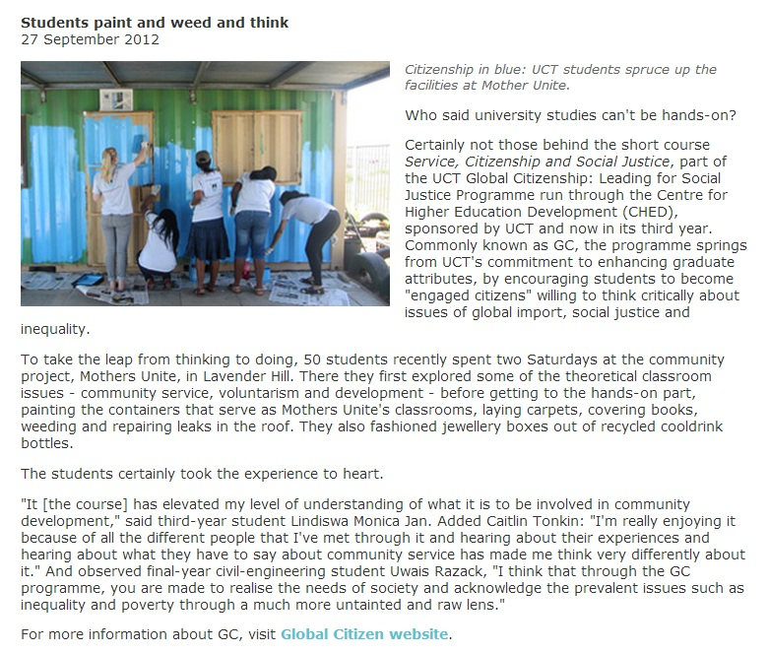

Article appearing in the UCT Monday Paper, September 2012

**C. Facilitating and hampering factors**

By way of concluding, we list both factors that facilitated and hampered progress during this implementation phase.

**Successes**

1. **Revised core course: new learning**. We are pleased with the changes and development in the short course – both the service component and the session linking citizenship and service. Besides providing the class with a ‘common text’ and giving many students an opportunity to go into a part of the city they had not gone to previously, it also provided a very concrete and real context in which to explore issues. An example here is the concept of ‘development’. Some student comments from blog posts are included below.

|  |
| --- |
| **3rd year Engineering student:** As a civil engineering student I often get drilled with the idea that we are in the business of development. There is an air of arrogance that comes with this and often I find myself thinking that students will imagine entering the work environment and going into communities on their white horse to help the less fortunate. Never have we been given the opportunity to critically evaluate what this so called development we are doing is, and yet we feel so proud throwing the word around. I feel the session [at Mothers Unite] re-iterated that development is just about the large infrastructure and services brought in, these things also have to have a place within the communities that are being developed, and agents must have an appreciation that development is something that occurs between people, and how their actions and choices can have social impacts.  **2nd year Humanities student:** Secondly, what I really took away from that Saturday was how, when I put myself in the situation of 'the people who we develop', my notion of development changes. I didn't realise that there was such a gap between my theoretically, logical thinking about the topic, and my gut-feeling, heart thinking about the topic. Does that make sense? I was challenged to put myself in the shoes - and bare-feet and hungry tummies and LIVES - of people who I typically understand as needing development. For the first time I understood in my heart and not just my head that development must listen to and consider what people feel they need and want. |

2. Students also really enjoy **reflective learning** and **engaging** with students **across the disciplines** and faculties at UCT.

|  |
| --- |
| **3rd year BSocSci student:**My greatest insight here was: the ability to truly understand the meaning and practice of critical thinking, analysis and reflection. I never realized just how powerful a tool it can be to stir you forcefully into the ‘right’ direction. It has inhabited inside me the need to really pay attention to my thoughts and thus exptrapolate the deepest meanings embedded inside them for THAT’s where the real answers lie. Another insight was that: the sharpest way to self development occurs when you surround yourself with people who challenge A LOT of your pre-composed notions/ideas and force you to give up your beliefs and to question every-single-thing, uncomfortably so, to get to a deeper understanding of the bigger scheme of things with issues like justice, service, identity and citizenship.  **3rd year Geomatics student:** My view has changed from my initial view of development, and this was facilitated by being in the midst of various people from different faculties and background. Their views were thought provoking and challenged me to remove the blinders that restricted my view on development and be weary of what people might actually need, rather than imposing our needs to them. This somehow overlaps with being of service to a person or community. |

1. **Working with tutors**: student (academic) leadership development. As in previous years, we used past GC students as tutors, who facilitated both the online and the face-to-face sessions. This provided an opportunity for students to gain valuable experience in facilitating learning and providing academic leadership. This is a key element of the programme that we wish to grow and develop.

**5. New media innovations**. We have been developing the ‘branding’ and identity of GC this year with a more active use of Facebook to communicate with all our students and attract new students. Since the GC programme now has students in three components – who sign up for three individual Vula course sites – we needed to find a way to keep the programme visible to all of them. The GC Facebook site was started last year, but has been used as a virtual GC community notice-board effectively. We have over 300 ‘likes’ and regular activity and comments on our posts. News and pictures about the current GC work are posted there, adverts for each new GC workshop theme for recruitment as well as publicity for other campus and public events of relevance to the GC values and themes. Trendy new t-shirts, buttons, banners and regular advertising of each workshop themes are ways in which we are beginning to make GC more visible throughout the year.

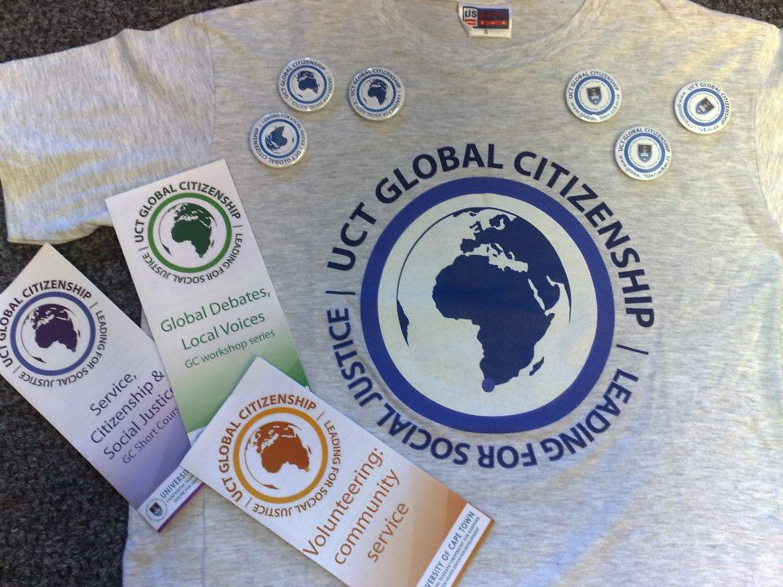

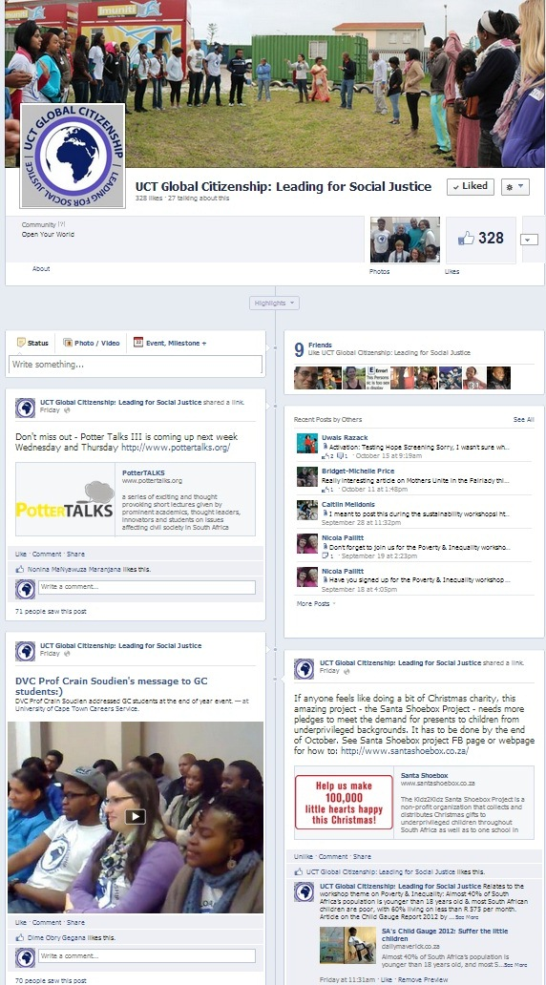

**Challenges**

The new GC Award programme design began this year. We believe that having the three components has added an important dimension to the programme and given student service and volunteering more value and profile. This is an important component of engaging students holistically and in them developing an awareness of critical issues facing both South Africa and the globe more broadly.

Having said this, we have had teething problems with the new programme some of which we have discussed above. Four of the main issues that have emerged through our experience this year are:

1. The flexibility of the workshop series design which has led to erratic attendance
2. Confusion among some students about how the three Award components related (which components they were registered for and what the requirements of each were)
3. Keeping participants on all three components connected in developing a broader GC community
4. The logistics of administering the new staged, multi-year programme.

In addition, the programme will lose 5 of the 6 tutors who have been involved as both students and tutors since the beginning of the programme as they are graduating at the end of this year. On the one hand this is a huge loss; however it is also an opportunity to develop a new cadre of student leaders on the programme.

**To conclude**: From our experiences thus far, there are a number of important lessons we have learnt, a number of which have been dealt with in the text above. We will use our review workshop later in October to make sense of these and to use them to plan for 2013.

Janice McMillan

Janet Small

UCT Global Citizenship Programme

[www.globalcitizen.uct.ac.za](http://www.globalcitizen.uct.ac.za)

Centre for Higher Education Development

University of Cape Town

October 2012

1. www.uct.ac.za/about/intro/
2. 2. This is a **short** course seen as the **core** course of the programme. We use these terms interchangeably in this report.
3. This figure includes students who registered for more than one component. Total number of individual students registered on the programme was 150.
4. The other themes are: War & Peace, Debating Development; Climate Change and Africa in a Globalised World.
5. Student C: “Our screening [of the DVD Testing Hope on the education crisis] went well - … we had a really great discussion afterwards”.

   ##### Student U: “Activation: Testing Hope Screening. Had more than 10 family members over, including two ex-principals. It made for a very meaningful discussion!”

  