HELTASA is a member of the International Consortium of Educational Development (ICED), which has 24 different national networks as members. As Chairperson of HELTASA, I attended the ICED council meeting in China on 6-7 July, in a very warm and humid Shanghai (36 degrees). The meeting was followed by the 2017 Chinese Higher Education Development (CHED) Network Conference at Fudan University.

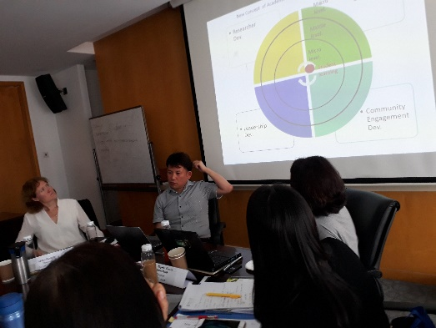The council meeting offered insightful perspectives on educational development matters at an international level. The first day focussed on ‘Hot Topics’ of national concern and challenges such as increased vulnerability of ED centres; increased advocacy role of AD practitioners; urgent SOTL focus through AD journals; and the sustainability and growth of new and existing networks. In my group, which focused on the role of AD, we discussed the relevance of educational/ academic developmental nomenclature in current times, and whether we needed to reconceptualise our work to signal changes in the modes and purposes of our work. New conceptions of AD/ED include a focus on the whole student learning experience rather than over emphasising teacher performance. Key players who ensure student success extend beyond the teacher in the classroom to include curricular and co-curricular aspects of the university. It was suggested we should embrace all aspects of support that ensure access and success.

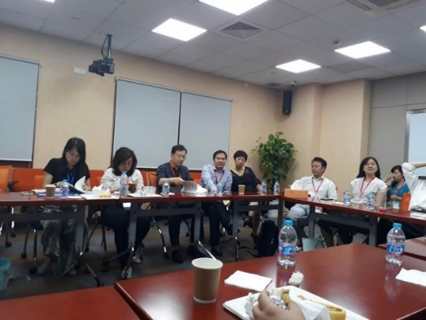The second day was a business meeting focusing on all aspects of governance and council matters. Council members were still in high praise of the joint HELTASA-ICED Conference in Cape Town in 2016 and commended our conference organising team (Chris Winberg and team) for an outstanding conference. They made special mention that the contextual challenges we faced provided very real lenses for them to understand educational development and its challenges in a more nuanced way. In fact, one council member from Sweden commented that it was the best ICED conference she had attended based on the richness of contextual issues that permeated the South African presentations and papers. Another council member from Switzerland commented that the affective aspects such as the poetry reading by Diane Ferris touched her and her colleagues in deep and profound ways. The next ICED council meeting will take place in Atlanta, at the ICED 2018 Conference. I was quick to promote our own HELTASA conference hosted by DUT this year and members said they would share the link with their networks.

The next 2 days were dedicated to the CHED conference. Like HELTASA, CHED is a professional network of university teachers across the country. Its aim is to promote education development in all universities by enhancing communication, sharing, coordination and cooperation among faculty development institutions and personnel, and teachers.

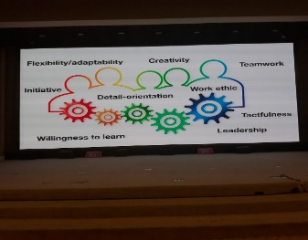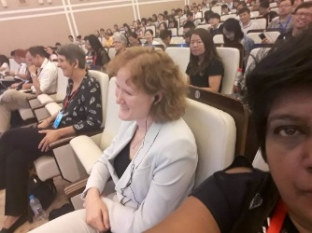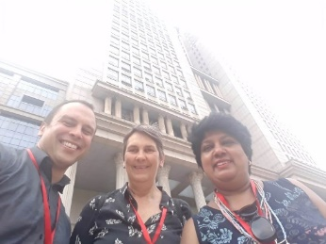

The conference, entitled Facilitating Deep Learning through Educational Innovation & Collaboration hosted 800 delegates from across China. To give you an idea of the scale of the conference there were 6 keynote speeches, 8 Pre-Conference Research Workshops, 72 papers in parallel sessions such as roundtable meetings, education development 1+1, teaching research reports, and 39 poster proposals. When the resources become available, we will share these on the HELTASA website.